WEEK 7

Mandatory Hands-On

**REACT**

**Creating an eventexamplesapp Application**

* *eventexamplesapp* application is created in the directory Week7\ using the command *npx create-react-app eventexamplesapp.*

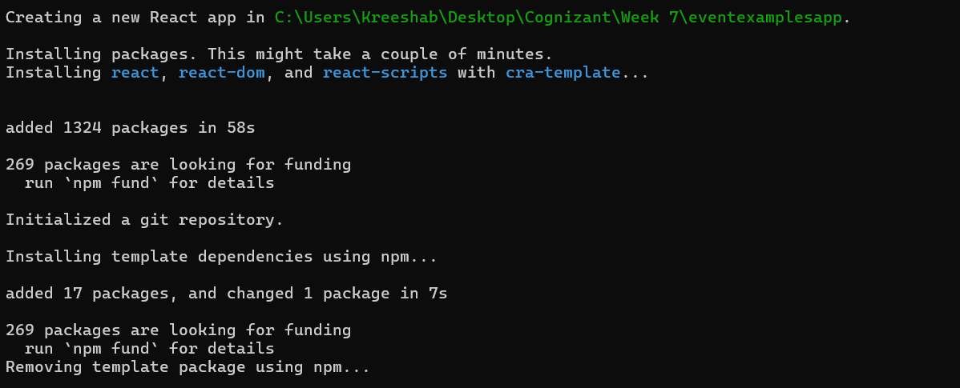

* Navigated to the React app and created CurrencyConverter Component inside components folder in src.

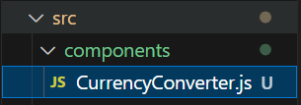

**App.js:**

import logo from './logo.svg';

import './App.css';

import {useState} from 'react';

import './components/CurrencyConverter'

import CurrencyConverter from './components/CurrencyConverter';

function App() {

  const [count, setCount]= useState(0);

  const increment= ()=>{

    setCount(prev=> prev+1);

    alert("Incremented count by 1");

  }

  const decrement= ()=>{

    setCount(prev=> prev-1);

    alert("Decremented count by 1");

  }

  const clicked=()=>{

    alert("I was Clicked");

  }

  const Message= (message)=>{

    alert(message);

  }

  return (

    <div className="App">

      <h1>{count}</h1>

      <button onClick={increment}>Increment</button>

      <br/>

      <button onClick={decrement}>Decrement</button>

      <br/>

      <button onClick={()=>Message('Welcome')}>Say Welcome</button>

      <br/>

      <button onClick={clicked}>Click on me</button>

      <br/><br/>

      <h1 style={{color:'greenyellow'}}>Currency Converter</h1>

      <CurrencyConverter/>

    </div>

  );

}

export default App;

**CurrencyConverter.js:**

import React, {useState} from 'react';

const CurrencyConverter=()=>{

    const [currency, setCurrency]= useState('');

    const rate= 0.011;

    const convert=()=>{

        return (currency* rate).toFixed(2);

    }

    return(

        <div>

            <input type="number" placeholder='Amount' value={currency} onChange={(e)=>setCurrency(e.target.value)}/>

            <button onClick={() => {}}>Submit</button>

            <br />

            <textarea

            value={currency ? `EUR: ${convert()}` : ''}

            readOnly

            rows="2"

            cols="25"

            />

        </div>

    );

}

export default CurrencyConverter;

**Sample Output:**

